PROJECT

Creating Ads in Social Media

Instagram Profile: -

https://www.instagram.com/morden_ethnic_rajkot/?__pwa=1
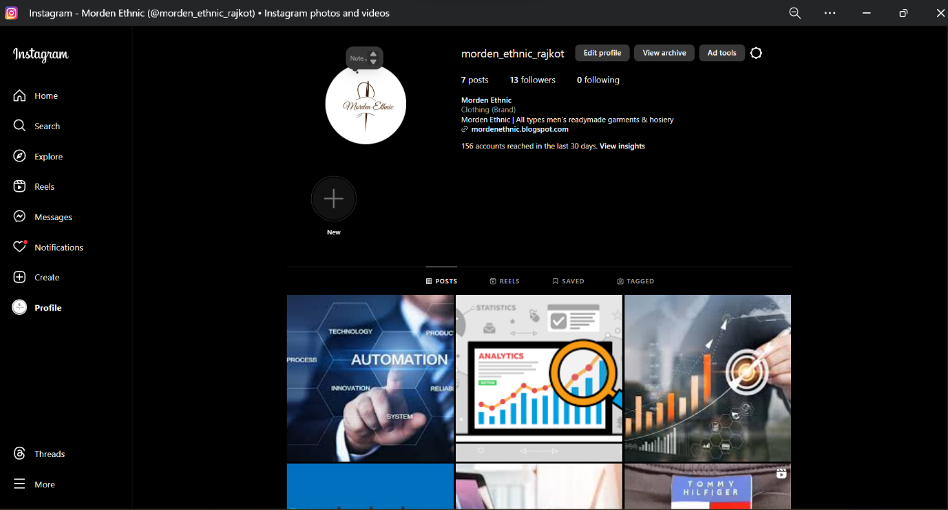

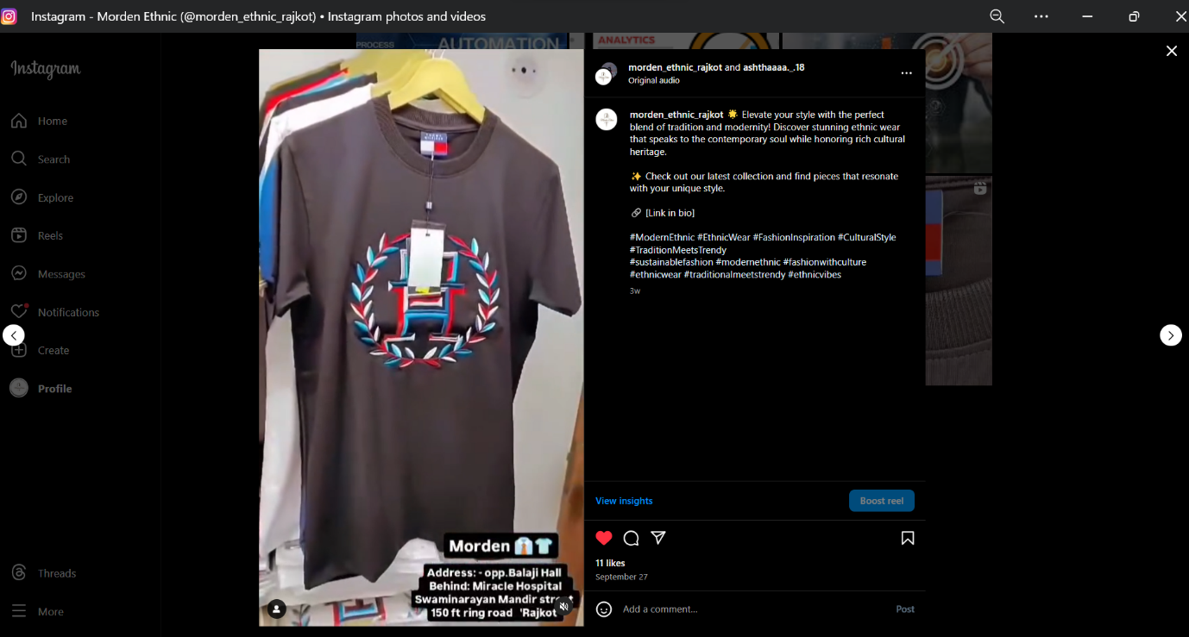

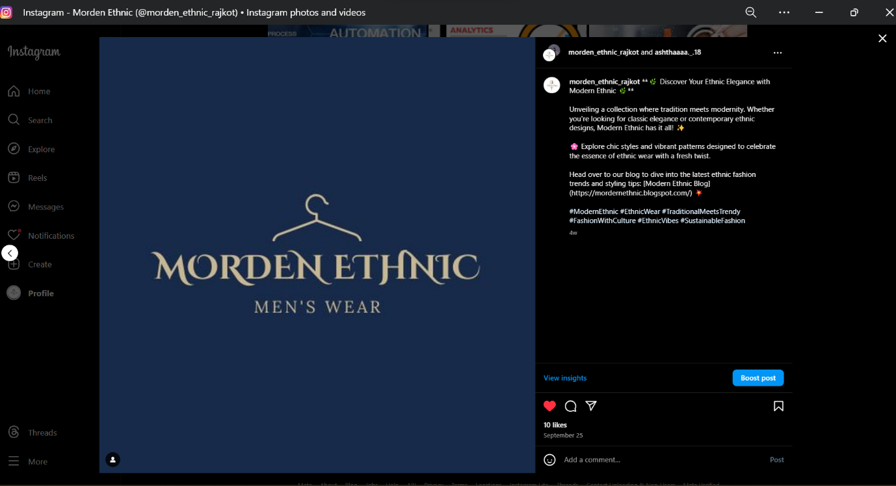

Facebook Profile: -

https://www.facebook.com/profile.php?id=61566330868811

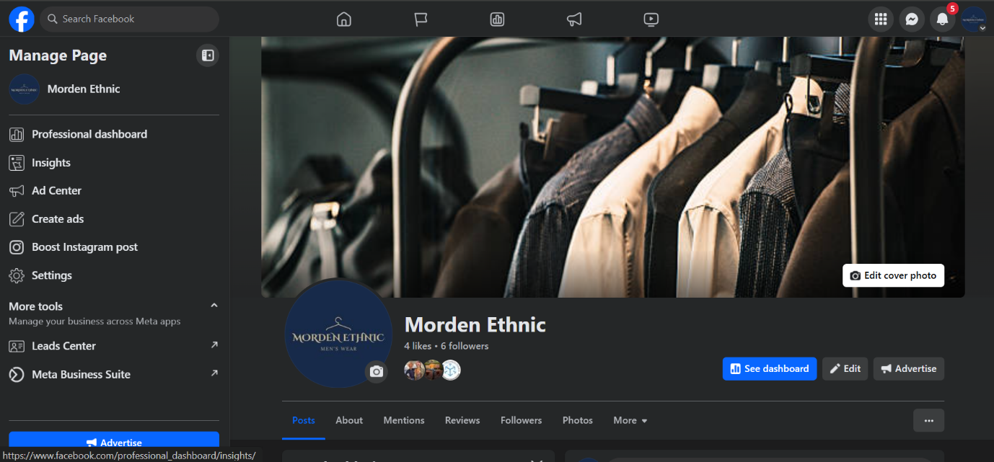

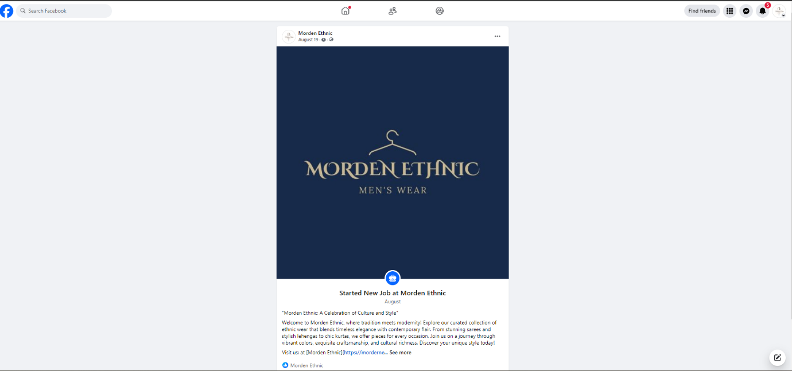

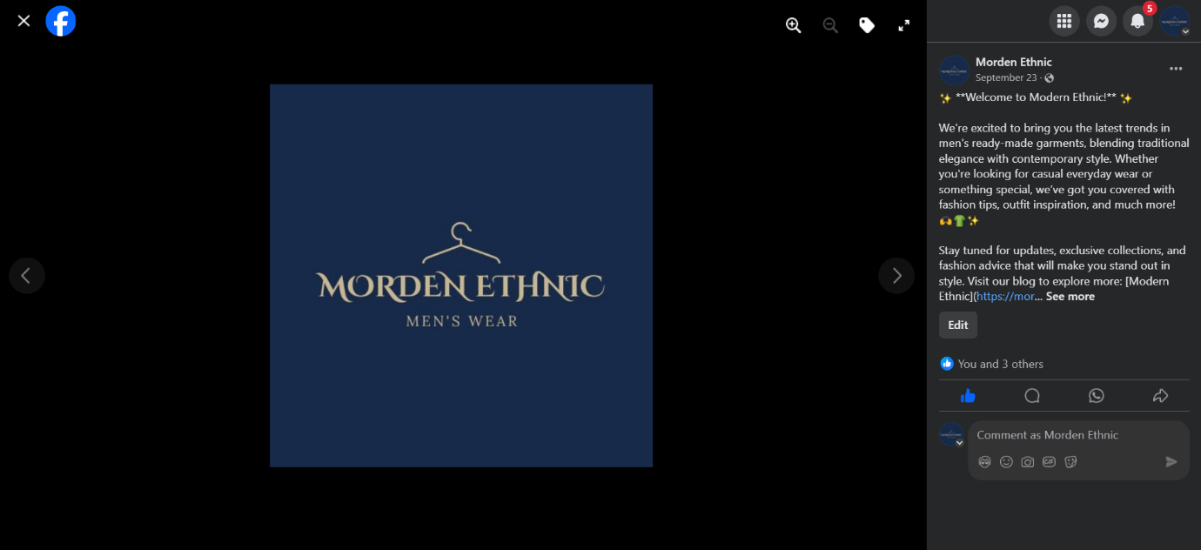

LinkedIn: -

https://www.linkedin.com/in/aastha-parmar-2b271b31a/

